MTH 4040 Coordinating Seminar
Technology Presentation Worksheet
Joseph Timmons

Graphing and Solving Inequalities Using Desmos

Desmos is an online graphing calculator that allows you to graph functions, plot data, evaluate equations, explore transformations, and in our case, solve inequalities.
First, you must go to https://www.desmos.com/calculator to access Desmos’ free online graphing calculator. An empty graph will appear.
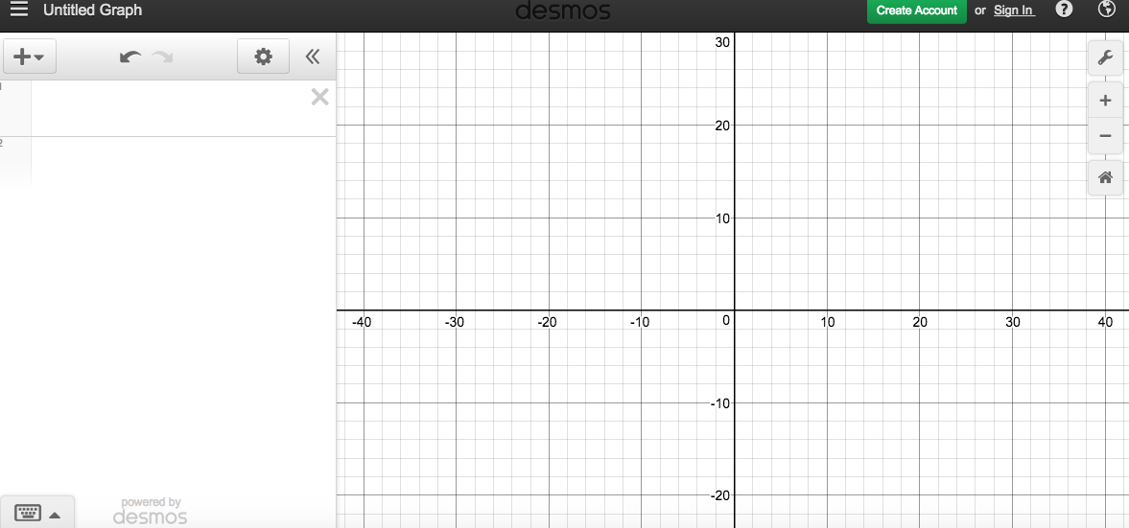
Let’s say you have to solve the following system of inequalities:
(2x + 4y < 6), (x - y > -1), & (y $≥$ -4).
The first thing we must do to solve our system of inequalities is to enter the inequalities as items to the left of the graph. You can enter these items using your own keyboard, or using the pop up keyboard Desmos provides you. If you decide to use your own keyboard there are several shortcuts to help you out. For example, if you type “x^2” Desmos will automatically convert that to $x^{2}$. Also, to enter the inequality symbol for greater than or equal to “$≥$”, all you would have to do on your keyboard is type >=, and Desmos will automatically convert your input. Below is Desmos’ pop-up “keyboard.”
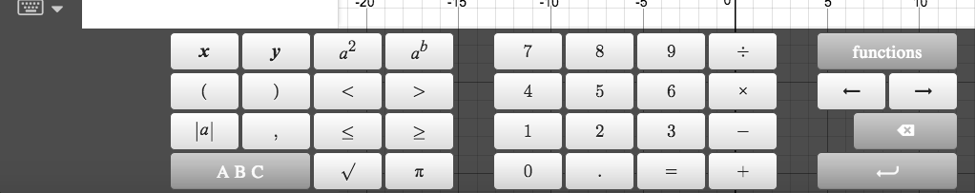
Now it is time to start inputting our inequalities. One great thing about Desmos is that we do not have to convert our inequalities into slope-intercept or “y =” form. We can input the inequality the way it is. So our first inequality is 2x + 4y < 6.
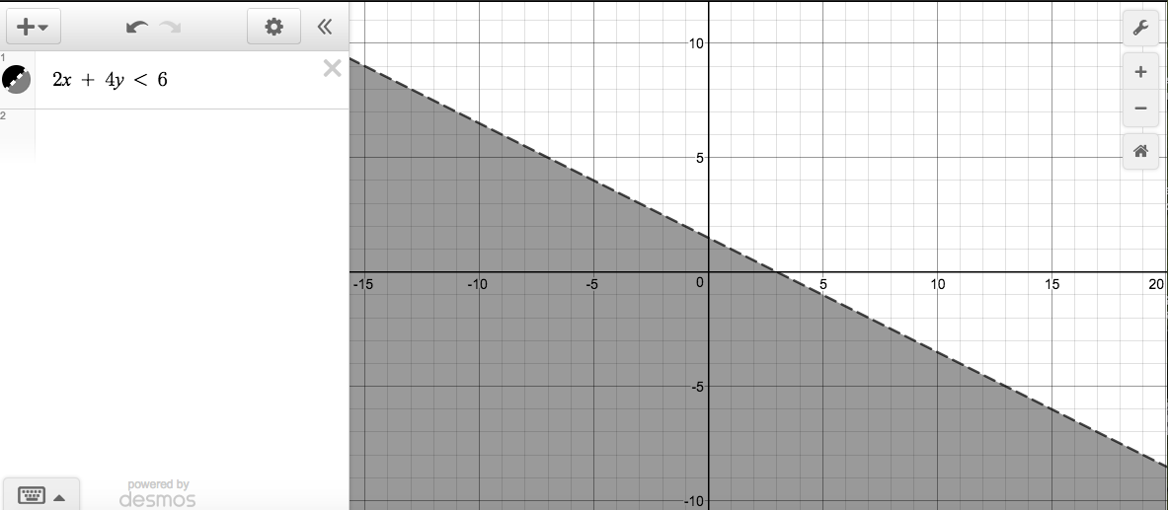
When we input our first inequality, Desmos automatically shaded the graph accordingly. Also, Desmos included a dashed line to show that the line is not included in the solution. Now we must input our second equation, x - y > -1.
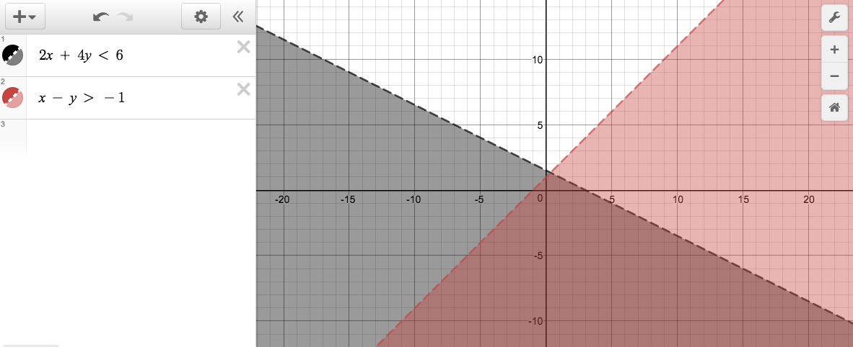
Desmos has included our new inequality on the graph, and has shaded the solution to that inequality a new and distinct color. You can also tell where the two solutions overlap. Now it is time to input our last inequality, y $≥$ -4.
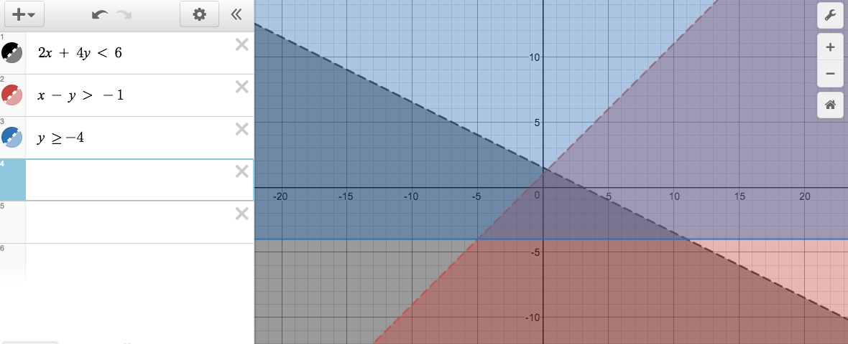
Desmos has included our third inequality with another new and distinct color shading. Also this time, since our inequality was “greater than or equal to,” Desmos included a solid line to indicate that the line is included in our solution. The solution to our system of inequalities is the portion of the graph that is overlapped by all three shaded areas. You can use your mouse to zoom in on the solution.
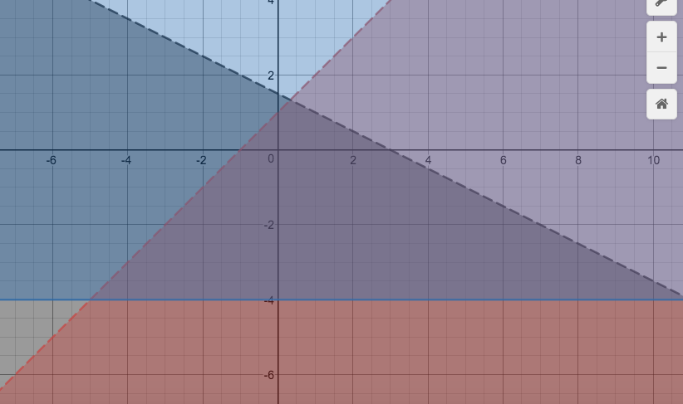
Solve the following Systems of Inequalities using Desmos:
- (y $≥$ 2x - 3), (y $≥$ -3), (y $≤$ 0.8x + 2.5)
- (3y $≥$ -2x + 12), (y $≥$ (-⅔)x +4) , (y < 2x - ¼ )
- (2x + 3y $≥$ -12) , (3x - y < 4) , (x + y $≤$ 4)

References

Desmos Graphing Calculator. N.p., n.d. Web. 05 Mar. 2017.
Desmosinc. "Learn Desmos: Inequalities." YouTube. YouTube, 18 Sept. 2015. Web. 05 Mar. 2017.

