Joseph Timmons
Math Behind Sudoku - Final Project

What is Sudoku?
Sudoku is one of the most popular puzzle games of all time. The goal of Sudoku is to fill in a 9×9 grid with digits so that each column, row, and 3×3 section contain the numbers between 1 to 9. At the beginning of the game, the 9×9 grid will have some of the squares filled in. Your job is to use logic to fill in the missing digits and complete the grid. Don’t forget, a move is incorrect if:
- Any row contains more than one of the same number from 1 to 9
- Any column contains more than one of the same number from 1 to 9
- Any 3×3 grid contains more than one of the same number from 1 to 9

History Behind Sudoku
The name Sudoku comes from Japan and consists of the Japanese characters Su (meaning 'number') and Doku (meaning 'single') but the game was not invented in Japan. Sudoku originated in Switzerland and then traveled to Japan by way of America. The modern Sudoku was most likely designed anonymously by Howard Garns, a 74-year-old retired architect and freelance puzzle constructor from Connersville, Indiana, and first published in 1979 by Dell Magazines as Number Place (the earliest known examples of modern Sudoku).
Sudoku Terminology
A “square” or “cell” refers to one of the 81 boxes in the sudoku grid, each of which is to be filled eventually with a digit from 1 to 9. A “block” refers to a 3 × 3 sub-block of the main puzzle in which all of the numbers must appear exactly once in a solution. A “candidate” is a number that could possibly go into a square in the grid.
Simple Solving Strategy Using Deductive Reasoning
Logical deduction or deductive reasoning is the process of using a rational, systematic series of steps based on sound mathematical procedures and given statements to arrive at a conclusion. In Sudoku, your “given statements” are the number clues given to you. You can use these to arrive at conclusions to what value should be placed in each square. For example, if eight of the nine elements in any row, column or block are already determined, we can come to the conclusion that the final element has to be the one that is missing since no element can be repeated. The most basic strategy to solve a Sudoku puzzle is to first write down, in each empty cell, all possible entries or candidates that will not contradict the One Rule with respect to the given cells. If a cell ends up having only one possible entry, it is a "forced" entry that you should fill in.

Solve This Sudoku:
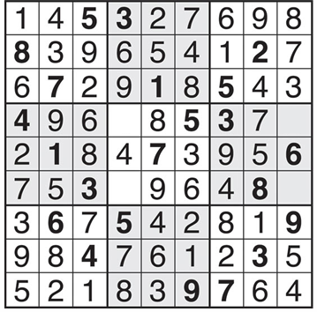

Math Behind Creating Sudokus
Cayley Tables of finite groups can be used to construct Sudokus. Take , the group of pairs, adding each component separately modulo some n. For a 9x9 Sudoku grid we would use n = 3 so that we would create an addition table for .
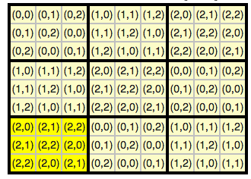

Now to officially create a Sudoku, we must permute the rows in such a way that each block is redistributed exactly once into each block. For example order the rows {1,4,7,2,5,8,3,6,9}. You could also permute the columns or even the different blocks. Once we rename each pair to a numeral between 1-9 then we have successfully created a Sudoku puzzle. Relabeling these 9 digits will also generate a brand new puzzle.
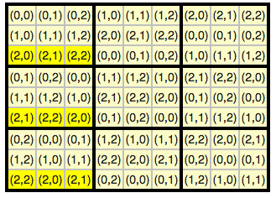
We can also transform Sudoku grids by using transformations. By applying transformations to a Sudoku grid we create completely new but still valid Sudoku grids. Our eight transformations are the following:
- Rotation by 0 degrees (the identity transformation). (R0)
- Rotation clockwise by 90 degrees. (R90)
- Rotation clockwise by 180 degrees. (R180)
- Rotation clockwise by 270 degrees. (R270)
- Reflection in the horizontal axis (through the center of the square). (H)
- Reflection in the vertical axis (through the center of the square). (V)
- Reflection in the diagonal from the bottom left to the upper right corner. (D)
- Reflection in the diagonal from the upper left to the bottom right corner. (D’)

Sudoku Puzzles for you to solve

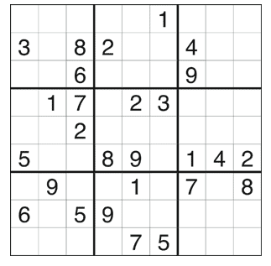

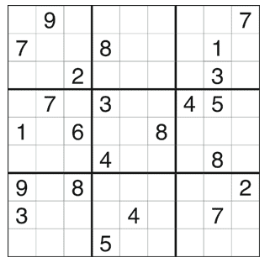

Solutions

